**Evaluation–5**

**Objective Check 5.1**

At the beginning of my project, I wrote some objectives that I wanted to complete in order to have a working project. I felt like by completing these my project would be of a high level and would create a web application I was proud of.

1. Create a calendar
2. Social networking aspect – profiles – groups
3. Database for profiles, groups and events
4. List all events and groups and have some sort of search for them
5. Login and register page
6. Be able to edit and save user, group and event information.
7. Create a calendar

I have created a calendar and shows all the months of the year and can carry on going to further years or can go into the past years as well. It also caters for leap years. The calendar also highlights in red the current day which was everything I wanted it to do originally.

1. Social networking aspect – profiles – groups

As seen in my testing each user has their own separate profile. I’ve done this utilising cookies, they are holding the UserID from when they log in. Similarly, each group has their own unique page this is also done by allocating the GroupID to a cookie.

1. Database for profiles, groups and events

Using MySQL I successfully created a database with 5 tables. I then used Docker which is a software that puts my database into a container that can be accessed from anywhere making my database mobile. Docker also decreases deployment times making my project run quicker as a vital part of my code is SQL queries.

I also used node js as it’s useful for back-end API services this is due to its single threaded nature. A lot of my code is just something happening when a button is pressed or when a page is loaded so it’s very useful.

Initially I had the three main tables, Users, Groups and Events but since they share a many to many relationships between themselves, I had to create two new linking tables: GroupMembers and EventGroups which link the respective tables together one to many relationships.

1. List all events and groups and have some sort of search for them

When the groups page or the events page is loaded the user is greeted with a table full of all the groups/events that have been created. On each of these pages is also a search bar with a search button so when they user enters a group/event name then press search the table will display all the groups/events that begin with the users input. If they users search also returns only one result, then they will be redirected to that group or events unique page.

This is all done through Ajax calls, API, and SQL queries. Ajax calls take the user inputted data and send it to the API for it to use the data to run the custom SQL query. Also by pressing the reset button the page is reloaded and the original table with all the results is shown again.

1. Login and register page

Users having individual accounts is a major part of my project so having a login and register page is especially important. A user can enter their own username and password then click register to create a new account. They can then re-enter this information to log in, this will send their username and password to the API to check it with the database to ensure the credentials are correct in order to get redirected to their profile.

When registering an account, the user's plaintext password is hashed using a salt then saved as the password in the database. This is done in case the database is breached then the hacker still cannot get the users actual password as we only save the hashed.

Throughout the project there is a log out button located at the top of the screen at all times, whenever this button is pressed it will first delete the user’s cookie holding their UserID then redirect them to the login page.

Also, if at any time the cookie holding the UserID is deleted or expires then the user is sent straight to the login page to log in again. This stops people leaving themselves logged in then someone else going on their account.

1. Be able to edit and save profile, group and event information

As seen in the tests the user can edit their profile page and change data such as their first name, last Name, bio or email then when they click the save button their data will be sent to an API through an ajax call which will then start an SQL query to update the database with the users new inputted data. This is done exactly the same in the groups page as well as the events page.

When clicking the edit button, a delete button also shows up which when clicked will delete the profile, event or group from the database, delete the cookie holding the ID information then redirect the user to either the login page, the groups page or the events page depending on what they have deleted.

**Conclusion**

After finishing my project I'm glad to say I completed all the objectives that I originally gave myself. The project was quite difficult for me, but I found it to be a great learning experience and I learnt important skills that I can definitely say I will be using later in my career.

**Feedback from Users 5.2**

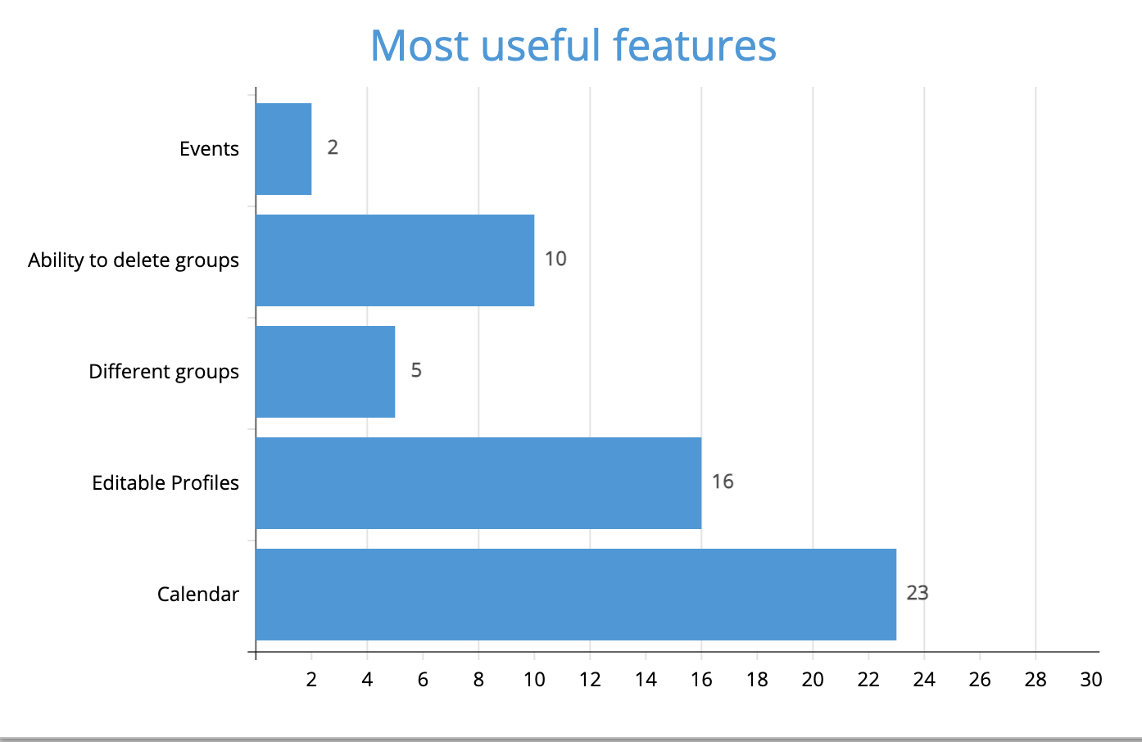

The first question I asked users was what is the most useful features. Winning by a lot was the Calendar and I'd agree, not only is a calendar very useful but it also has the most potential to be a huge part of the social network app. I think if I had more time, I would definitely focus on the calendar and make it something really special.

An outlier in the data shown was the Events, they only received two votes. Events do not do a lot in my project, but they also have the potential to be something special. I think by developing the calendar the events would also develop as you could link the events to specific dates in the calendar also you could link the dates to specific groups making them group exclusive or you could have multiple groups contain the same event as if it were a group lunch between companies.

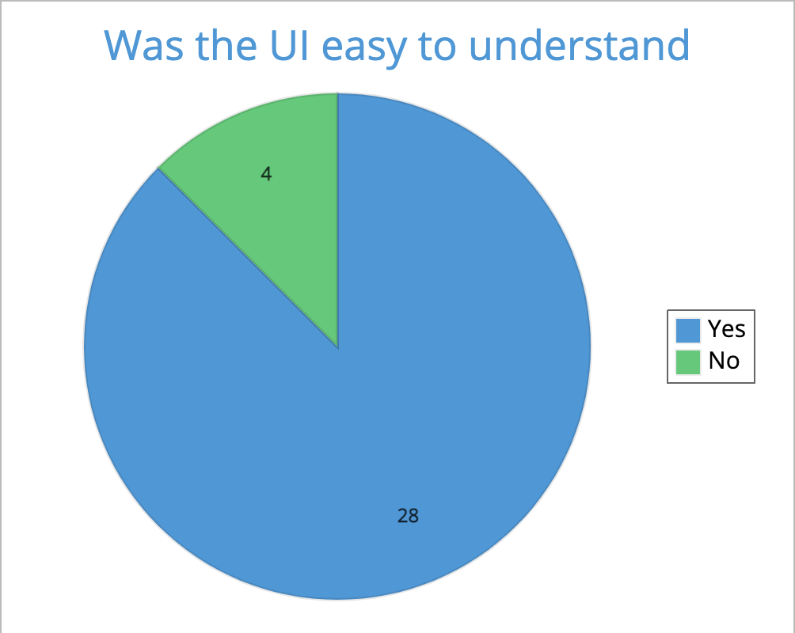

When investigating the different websites and apps in my analysis chapter I noticed how nice all of the user interfaces were and how simple they were to follow. Also when doing my survey a huge number of participants mentioned that the clean and simple website is something that pulls them in to using it and especially coming back to it.

So when I received the overwhelming amount of yeses to this question I was very happy with how I did. The reason my interface was so clean was down to using bootstrap to help with my html, they simplify the html code and also have a lot of templates to take inspiration from as well as tutorials and resources to learn from.

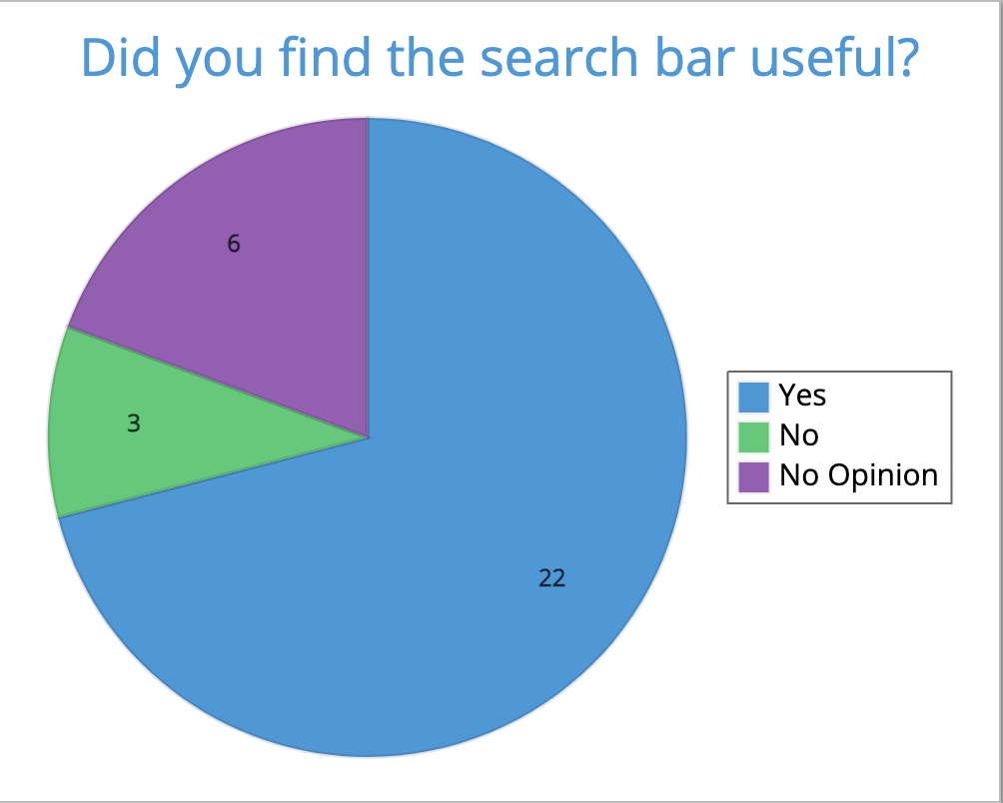

The search bar was something I wanted to add in instead of just having a button next to each possible group to get their page. I thought it would have enhanced the users experience by speeding up how they find the groups they want. The search bar also becomes more effective the more groups or events there are which might mean I wasn’t able to utilise it as much as I possibly could due to my low amount of groups of events but If I was to launch this app globally this chart shows me how the users agree with how useful it would be.

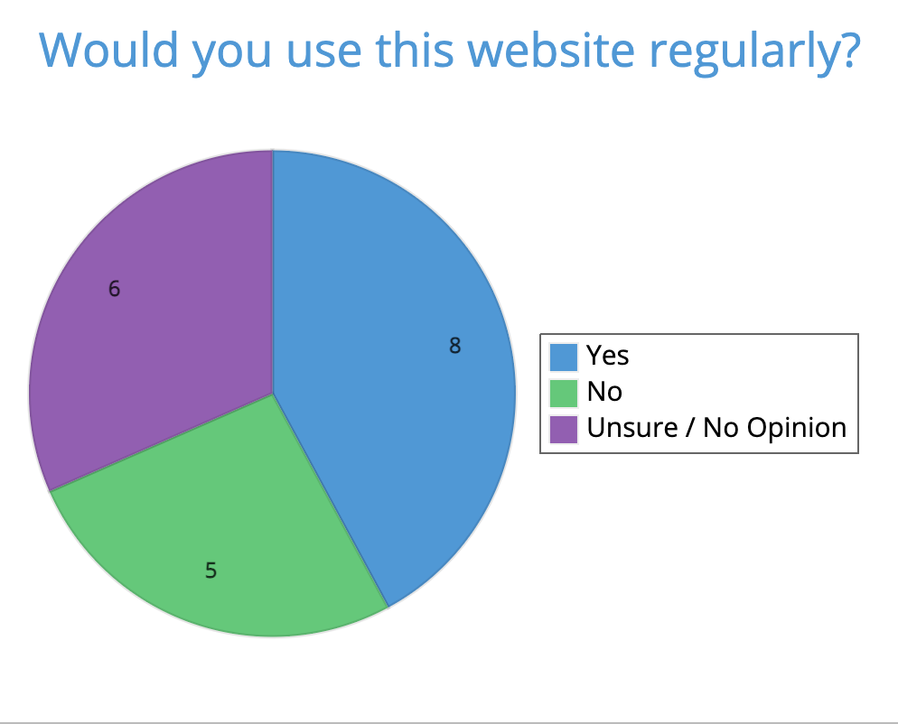

The results of this question came back quite average which is understandable for a unfinished project. Compared to big sites like Facebook, Instagram or snapchat a simple website doesn’t match up but with a similar yes to no’s shows how there's potential for a very promising website.

As I discovered from my research in the analysis chapter the biggest differences between the big social networks is the content at display, and the UI. I can proudly say the interface of my website was clean but can definitely be improved.

**Potential improvements 5.3**

One of the things I wanted to add but did not have enough time to do was the implementation of google location API with my event page. By doing this I could have shown exactly on google maps where the event location was and also provided directions to the event from the users current location.

Similar to that idea I could've had a new page that was a map of the local area and it had pins of all the events that were happening nearby. This also could have been used to show a user’s location after they had given permission, similar to how snap maps work on snapchat.

I could have also maybe added a chat room feature to the groups page or maybe a feed where you can post a small message from your account onto the group page or a feed similar to how facebooks feed works.

Another thing I could have added was maybe some customisation to the users profile page, possibly letting them do their own css like oldstyle myspace did or giving them colours and background pictures that they can either pick from or take from the internet themselves.